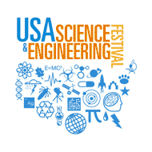
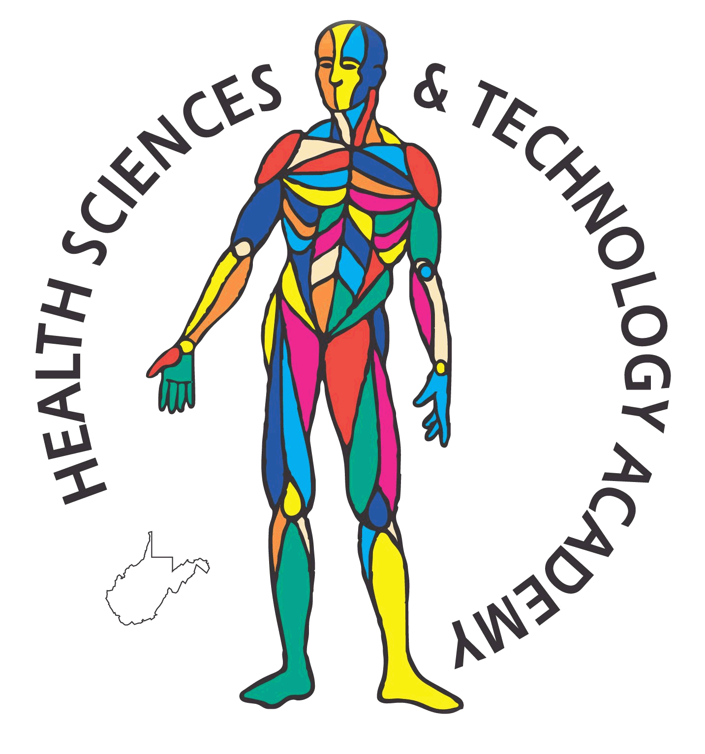

HSTA Students Represent the National Institutes of Health at USA Science and Engineering Festival in Washington, DC

Seven Health Science and Technology Academy (HSTA) students traveled to Washington, DC on September 22 - 25, 2010 to represent the National Institutes of Health (NIH), the National Center for Research Resources (NCRR), and the Science Education Partnership Award (SEPA) at the inaugural USA Science and Engineering Festival.
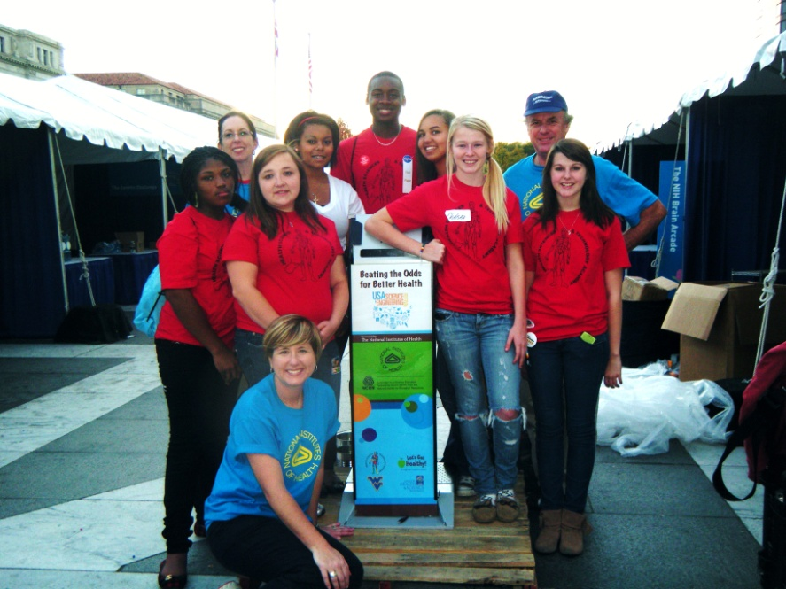
Back from left: Cathy Morton-McSwain, Ashley Uphold, Errin Baynes, Jasmine Dickerson, Dr. Tony Beck
Middle from left: Quintina Parsons, Aleesha Estep, Chelsea Freshwater, Mariah Campbell
Seated: Sara Hanks

This event was held at locations across the Nation’s capital with the mission of re-invigorating the interest of our nation’s youth in science, technology, engineering and math (STEM) by producing and presenting the most compelling, exciting, educational and entertaining science gatherings in the United States. Presenters from colleges and universities, government and federal research laboratories, Science and Engineering Outreach organizations, as well as professional Science and Engineering societies all had booths at this event.
HSTA students worked at a booth representing the NIH, NCRR, and SEPA with a team from Oregon Health Sciences University. The booth featured the HSTA healthy lifestyle survey that gave participants feedback on their risk factors for developing Type II diabetes and cardiovascular disease as well as information about diet and exercise. An additional survey gave festival goers information about their sleep as well as body composition and body mass index. The seven students worked tirelessly guiding participants through the exhibit and giving information about healthy living and still had time for a little sightseeing in the Nation’s capital.
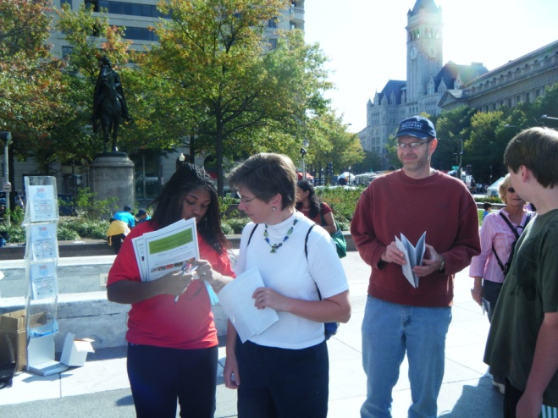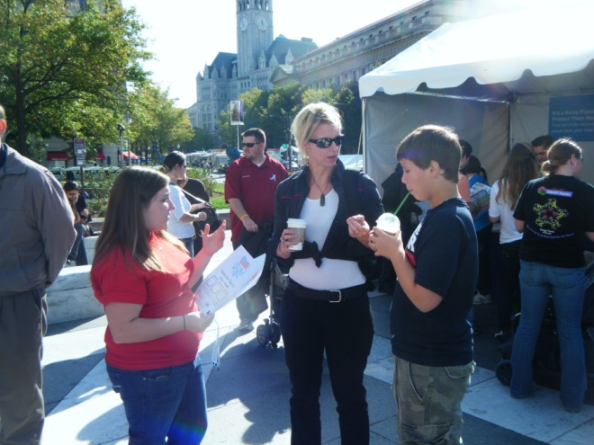
Quintina Parsons assists a participant with their wristband. Aleesha Estep explains the surveys to a participant.

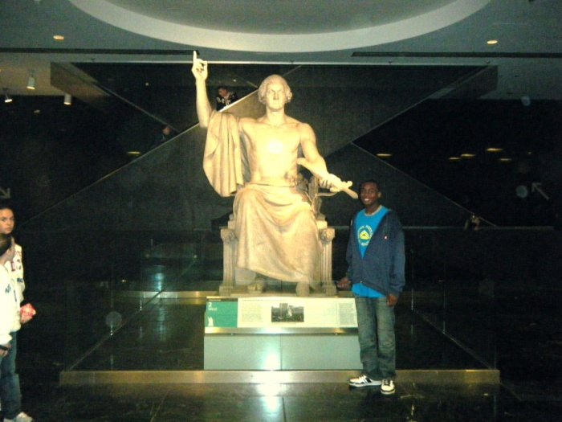
Errin Baynes takes time to capture a picture with George Washington at the
Smithsonian Museum of American History

